Chapter 9

Project Resource Management

Importance

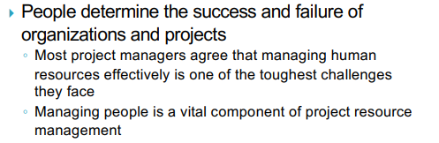

The Global IT Workforce

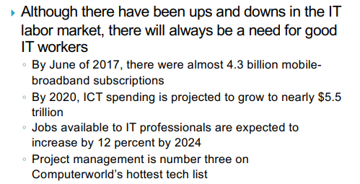

Implications for the Future of IT Human Resource Management

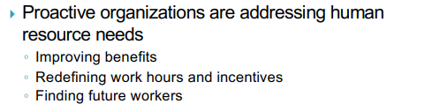

Global Issues



What Went Wrong?

} CompTIA found a gap between skills that employers wanted and what they actually found in the IT workforce

◦ 68 percent of IT firms report having a very challenging time finding new staff ◦ 52 percent of organizations report having job openings, and 33 percent say they are understaffed, while 42 percent say they are fully staffed but want to hire more people in order to expand

◦ 58 percent of businesses are concerned about the quality and quantity of IT talent available for hire ◦ Top technology priorities in this survey included security, data storage, and network infrastructure

◦ The number one strategy to handle understaffing is requiring workers to put in more hours

◦ 94 percent of IT professionals plan to pursue more training

Project Resource Management

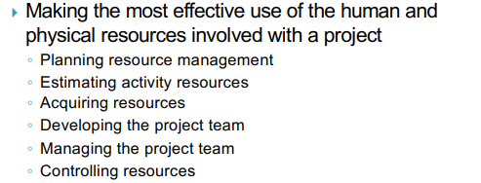

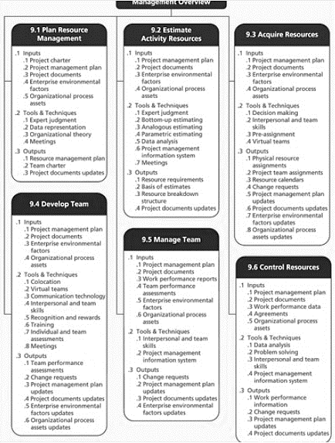

Keys to Managing and Leading People

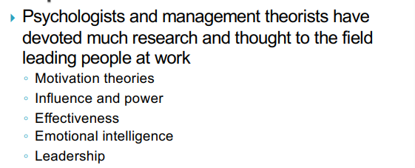

**Motivation Theories**

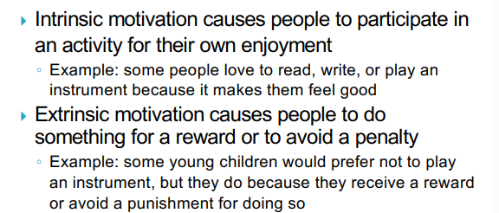

**Maslow’s Hierarchy of Needs**

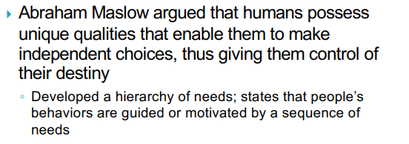

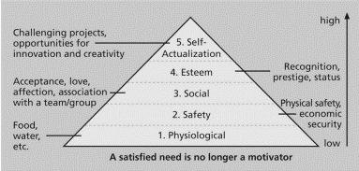

**Herzberg’s Motivational-Hygiene Theory**

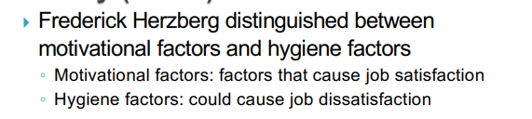

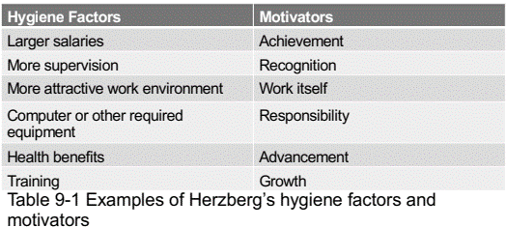

**Media Snapshot**

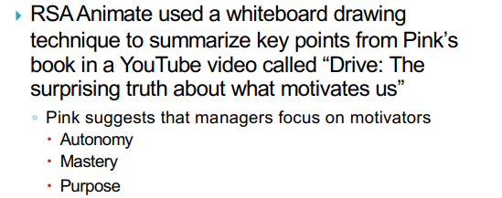

**McClelland’s Acquired-Needs Theory**

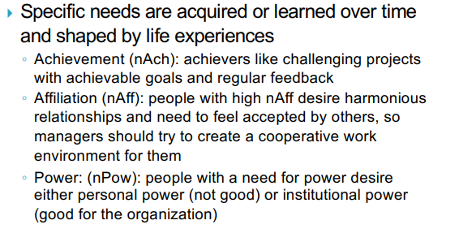

**McGregor’s Theory X and Y**

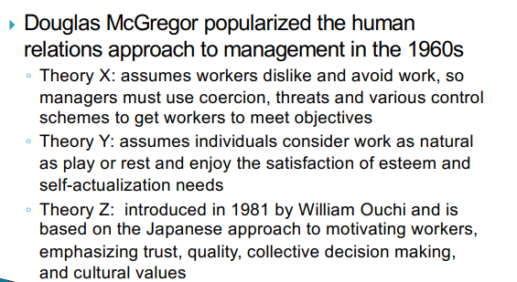

**Influence and Power**

} Thamhain and Wilemon: ways to have influence on projects

◦ Authority: legitimate hierarchical right to issue orders ◦ Assignment: ability to influence a worker's later work assignments

◦ Budget: ability to authorize others' use of discretionary funds

◦ Promotion: ability to improve a worker's position

◦ Money: ability to increase a worker's pay and benefits ◦ Penalty: ability to cause punishment

◦ Work challenge: ability to assign work that capitalizes on a worker's enjoyment of doing a particular task

◦ Expertise: perceived special knowledge that others deem important

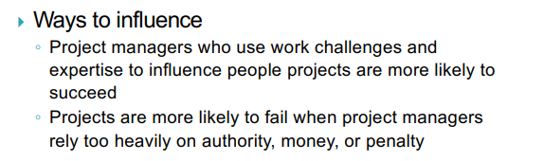

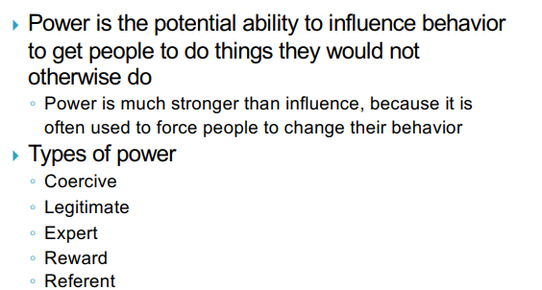

Covey and Improving Effectiveness

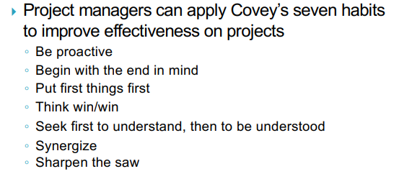

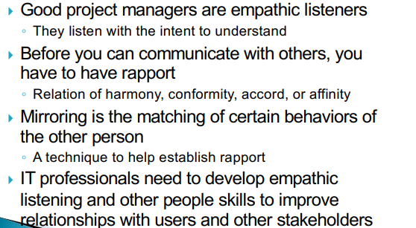

Advice for Young Professionals

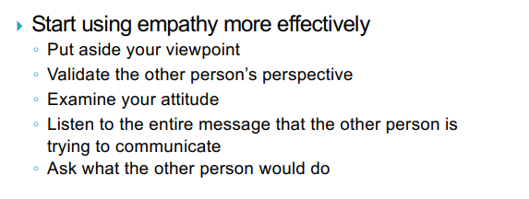

Emotional Intelligence

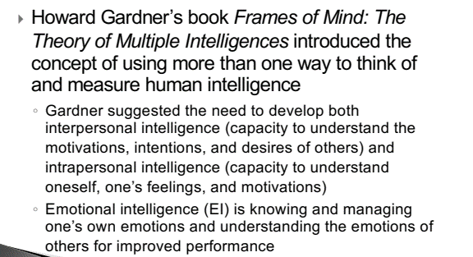

Leadership

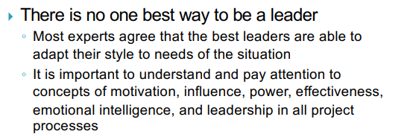

What went right?

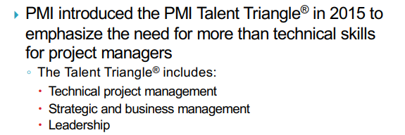

Developing the Resource Management Plan and Team Charter

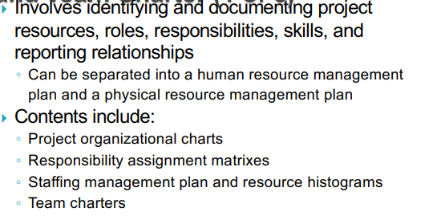

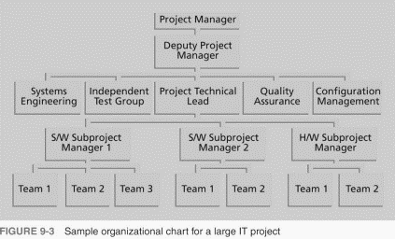

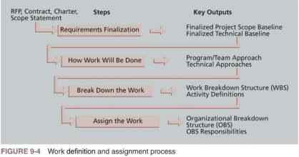

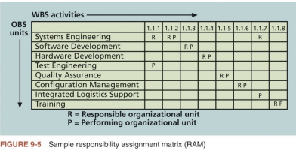

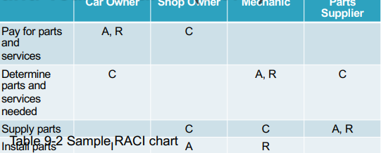

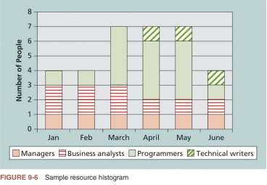

Estimating Activity Resources

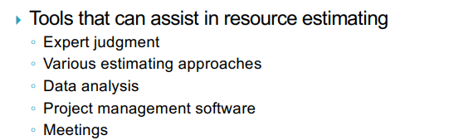

Acquiring Resources

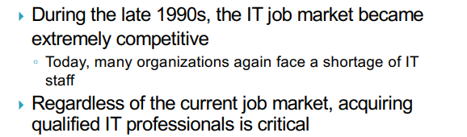

Resource Assignment

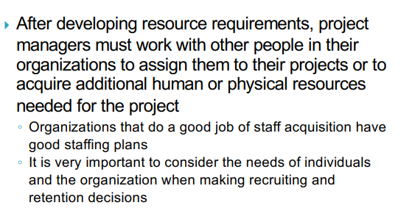

Best Practice

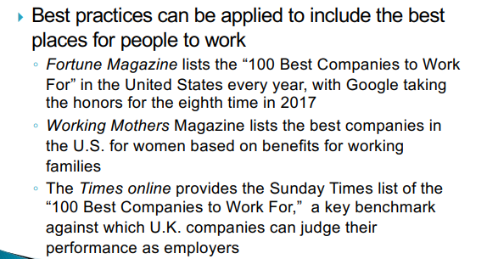

Resource Loading

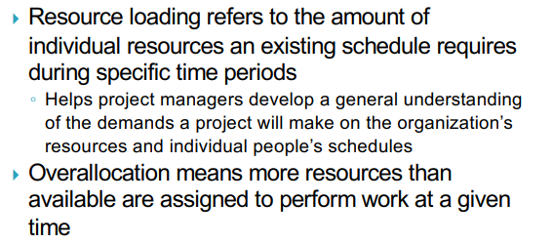

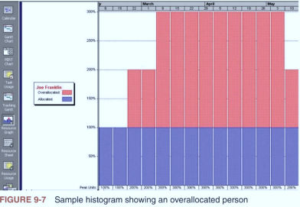

**Resource Leveling**

} Resource leveling is a technique for resolving resource conflicts by delaying tasks

◦ Main purpose is to create a smoother distribution of resource usage

} Benefits of resource leveling ◦ When resources are used on a more constant basis, they require less management

◦ May enable project managers to use a just-in-time inventory type of policy for using subcontractors or other expensive resources

◦ Results in fewer problems for project personnel and accounting department

◦ Often improves morale

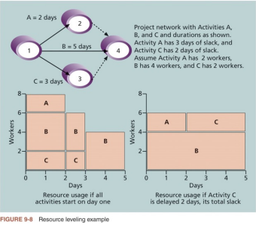

Developing the Project Team

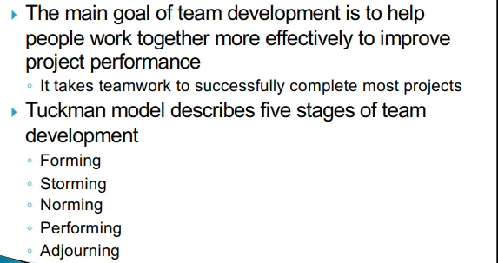

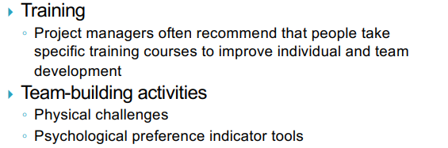

The Meyers-Briggs Type Indicator

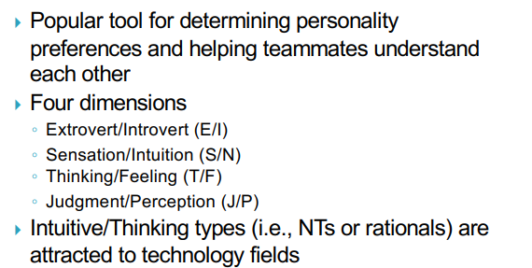

**The Social Styles Profile**

} People are perceived as behaving primarily in one of four zones, based on their assertiveness and responsiveness

◦ Drivers

◦ Expressives

◦ Analyticals

◦ Amiables

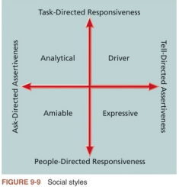

**DISC Profile**

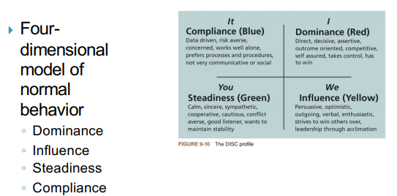

**Reward and Recognition Systems**

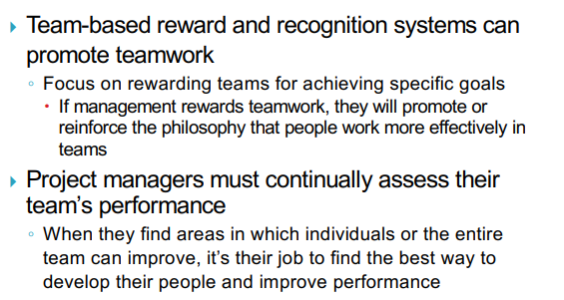

**Managing the Project Team**

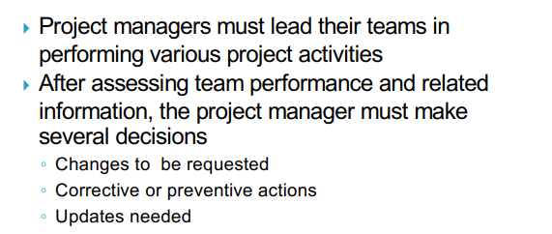

**Tools and Techniques for Managing Project Team**

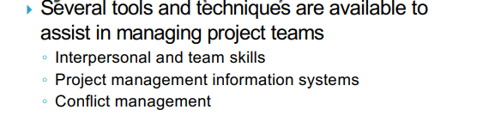

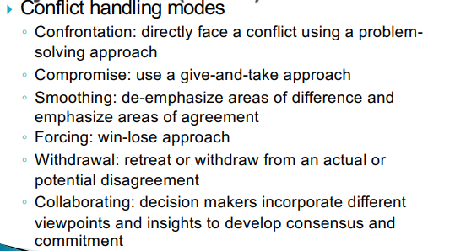

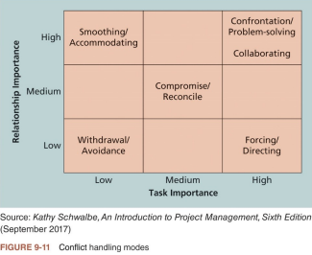

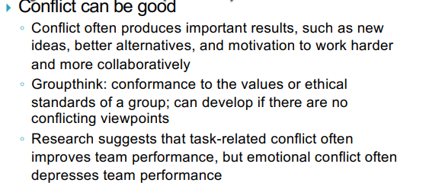

**General Advice for Managing Teams**

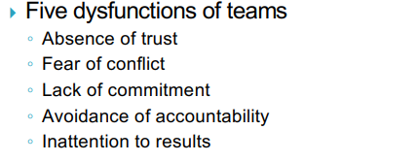

} **General advice**

◦ Be patient and kind with your team

◦ Fix the problem instead of blaming people

◦ Establish regular, effective meetings

◦ Allow time for teams to go through the basic teambuilding stages

◦ Limit the size of work teams to three to seven members

◦ Plan some social activities to help project team members and other stakeholders get to know each other better

◦ Stress team identity

◦ Nurture team members and encourage them to help each other

◦ Acknowledge individual and group accomplishments

◦ Take additional actions to work with virtual team member

**Controlling Resources**

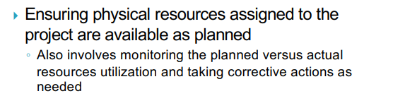

**Using Software to Assist in Resource Management**

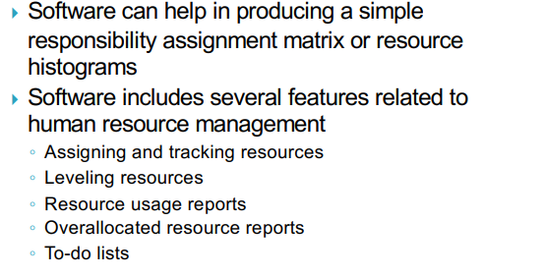

**Considerations for Agile/Adaptive Environments**

